**Name: Sanjana Singh**

**Registration No.: 19BCE10274**

**Mentor’s Name: Uma Rani**

**World Population Data Analytics using IBM Cognos**

1. IBM Cloud Creation

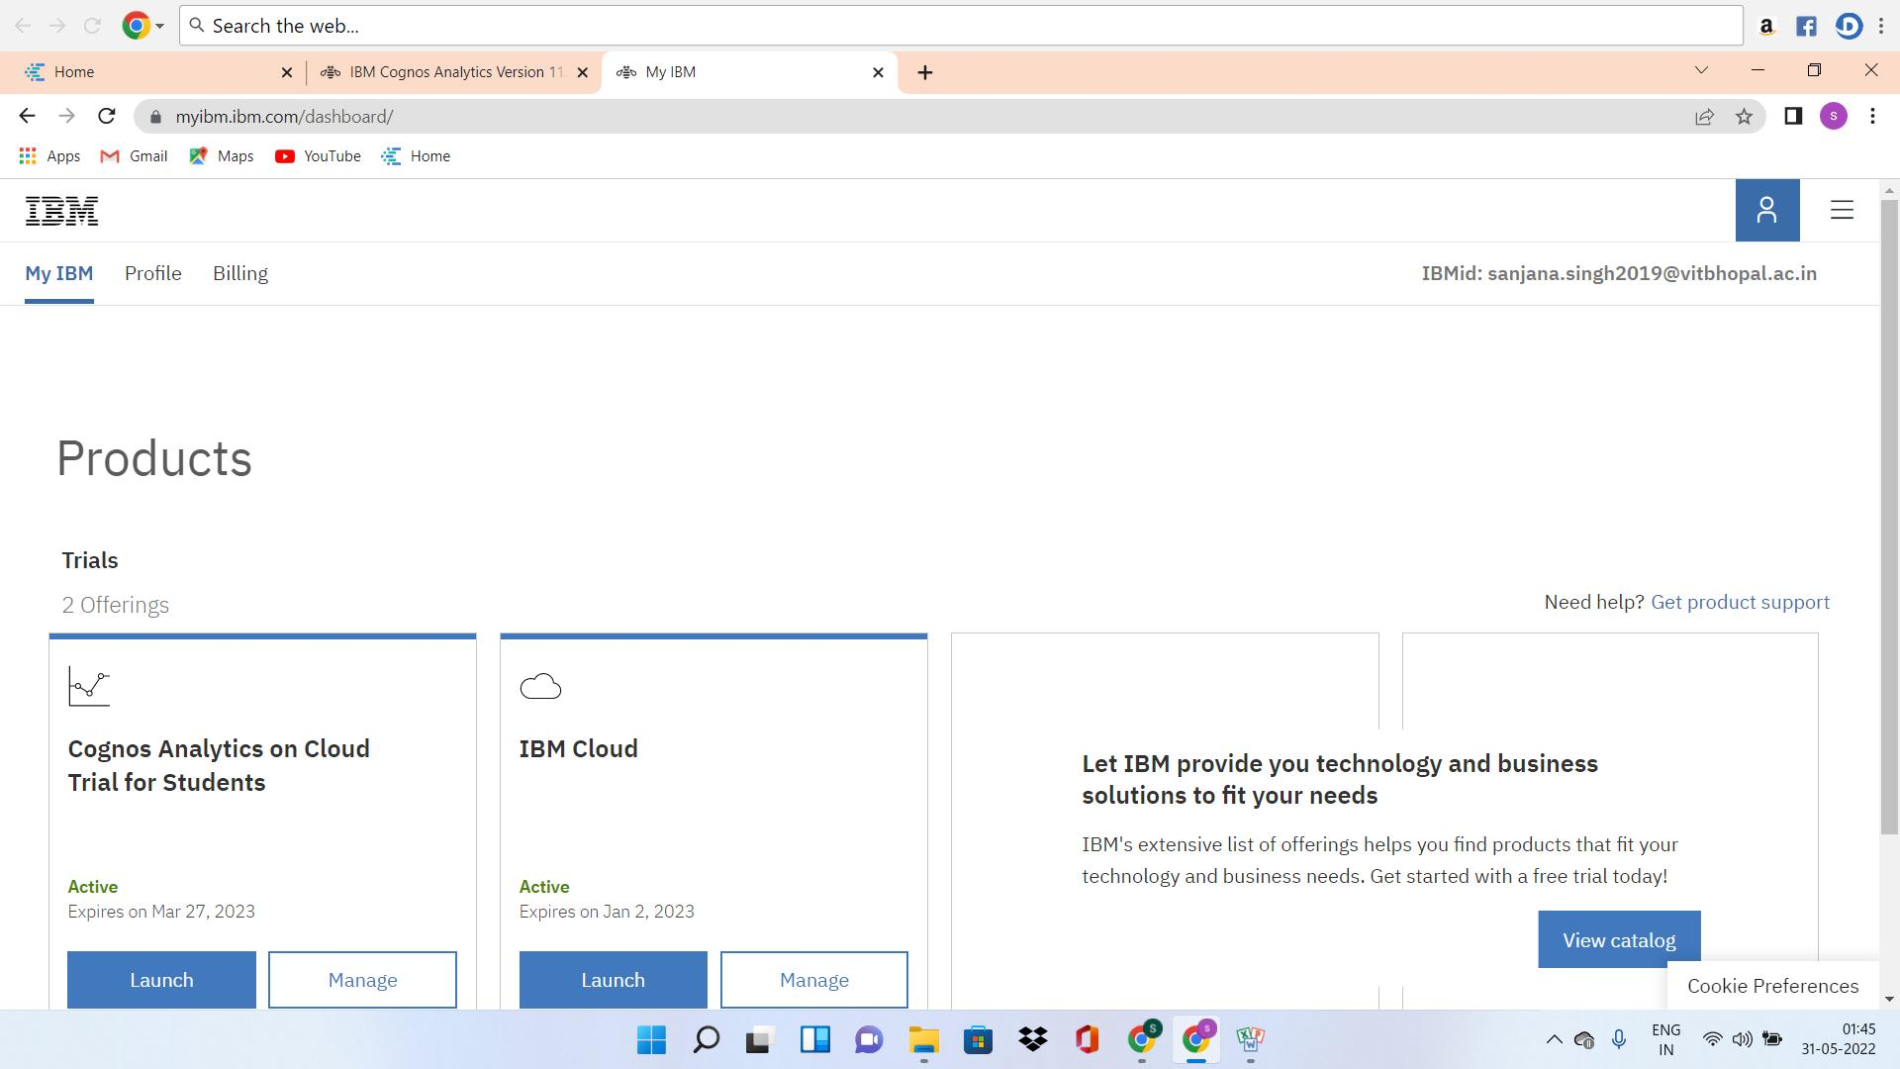

1. IBM Cognos Analytics

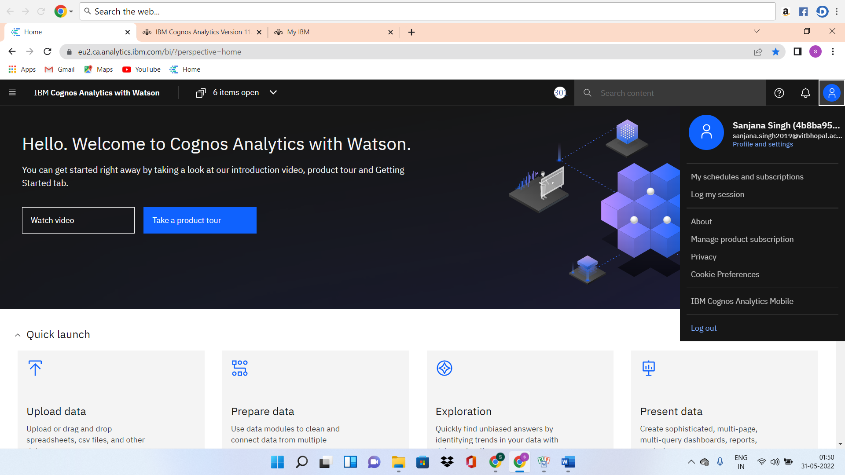

3. Working with the dataset

3.1 Understand the dataset

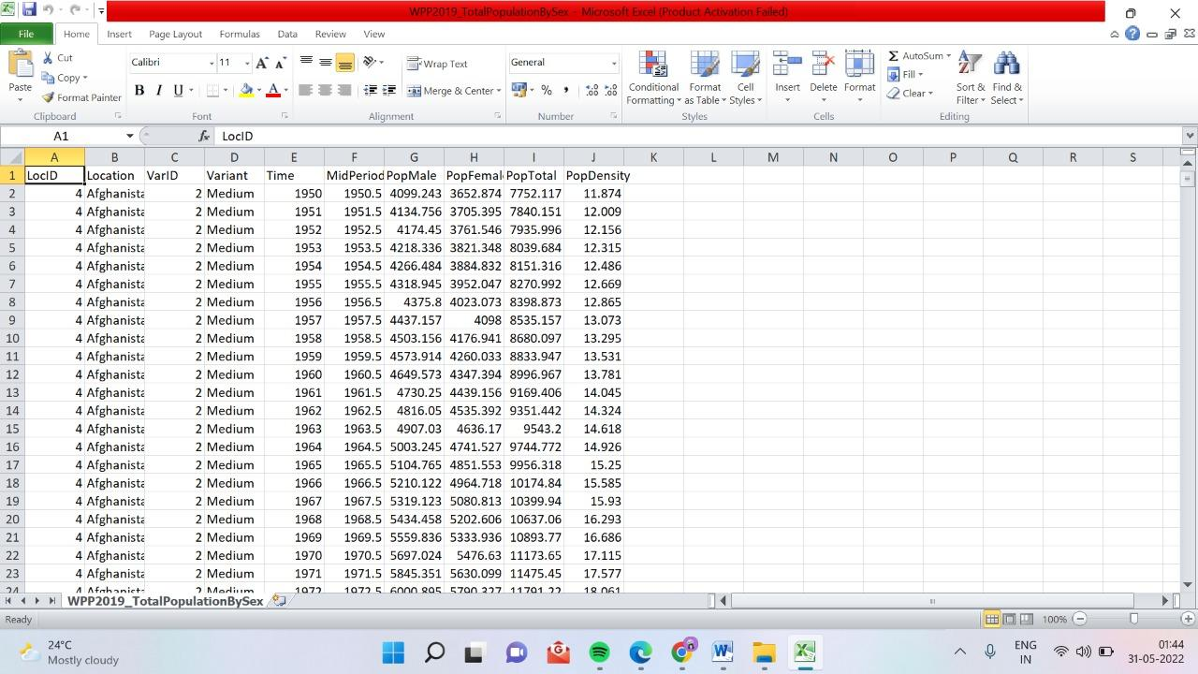

3.2 Loading the dataset

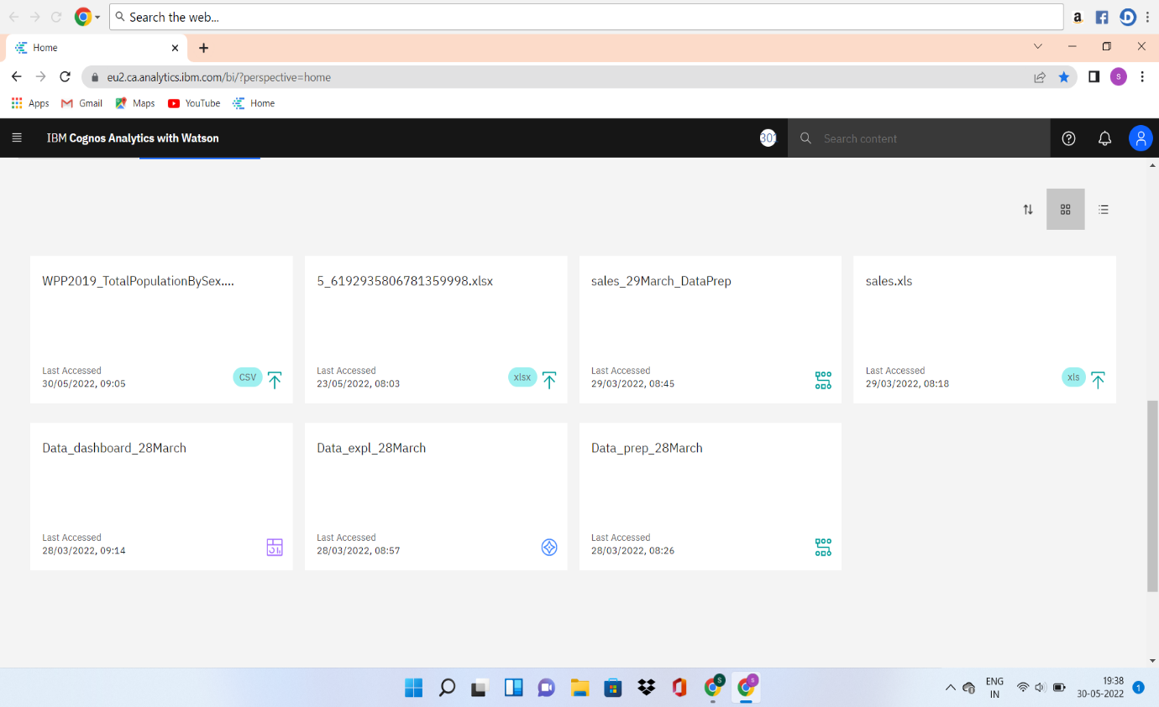

3.3 Prepare the datasets

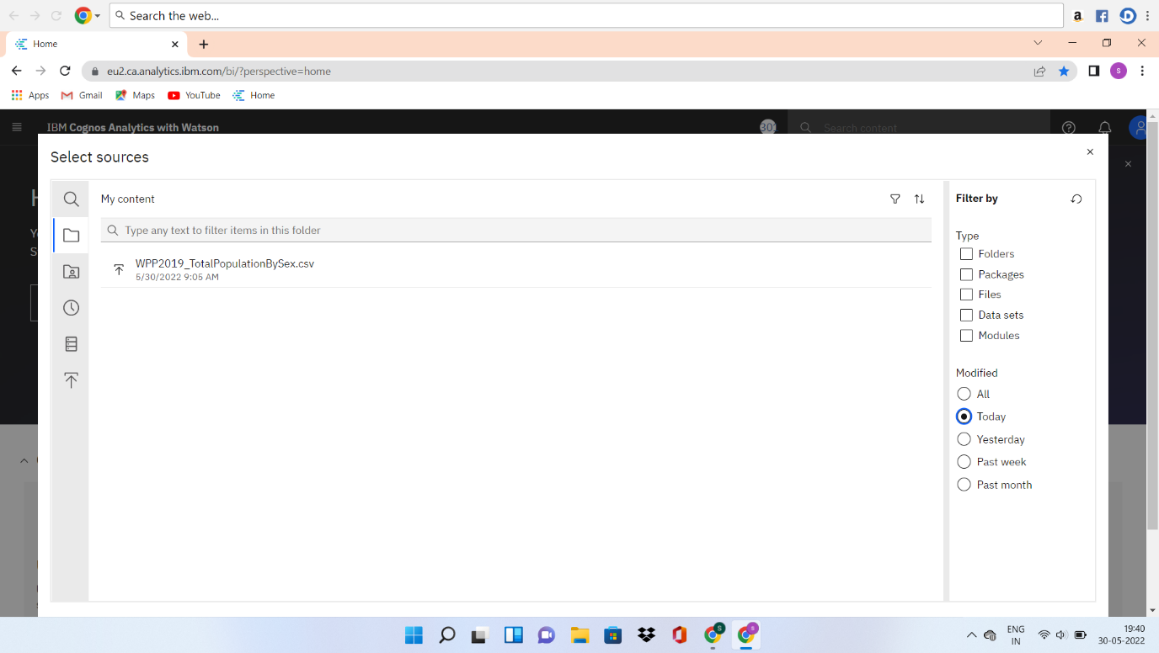

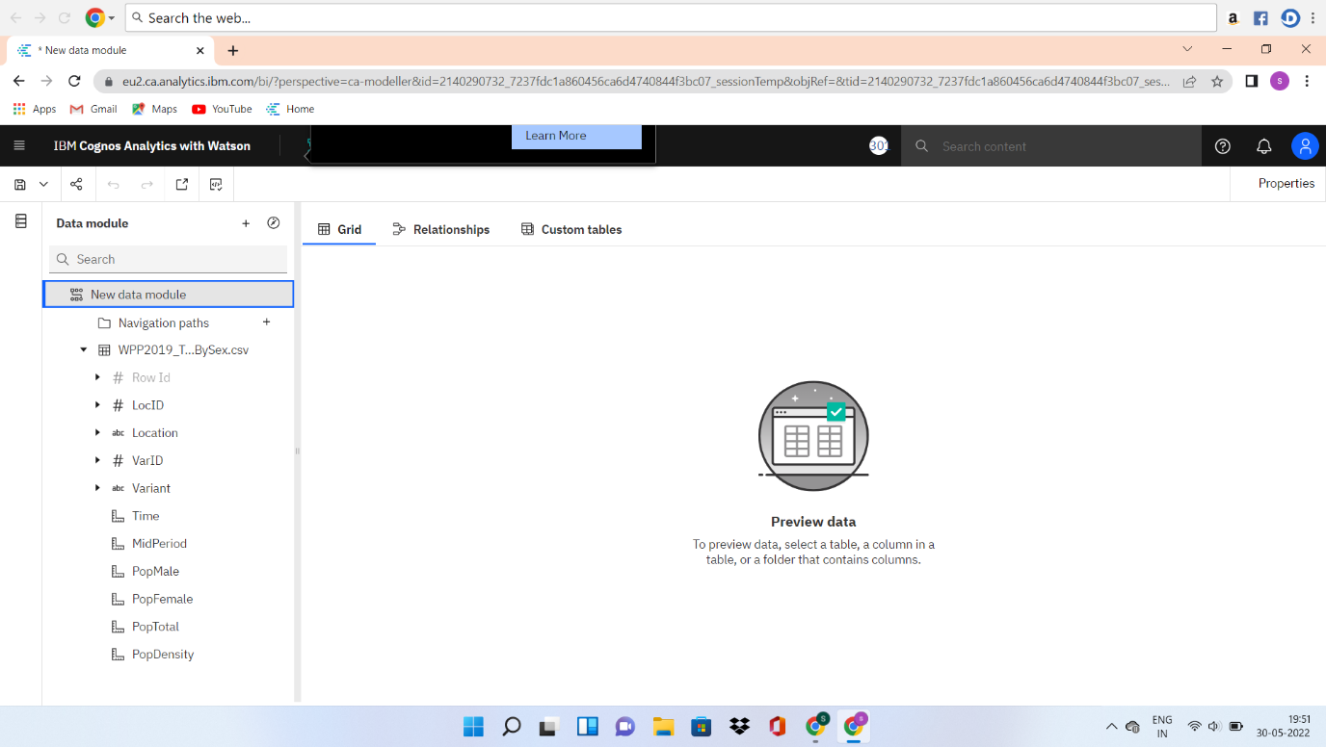

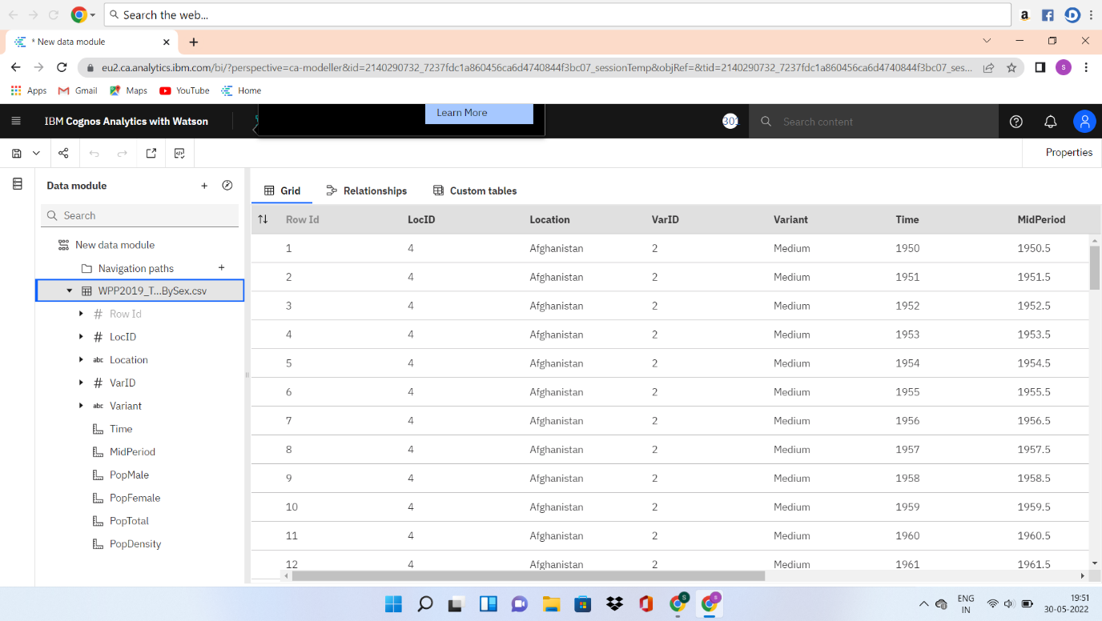

* Removing the existing PopTotal column

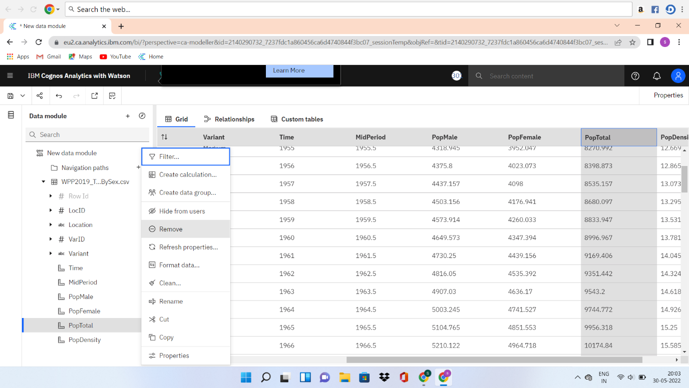

* Calculating the new PopTotal column. PopTotal = PopMale+PopFemale and validate the expression to formate the data.

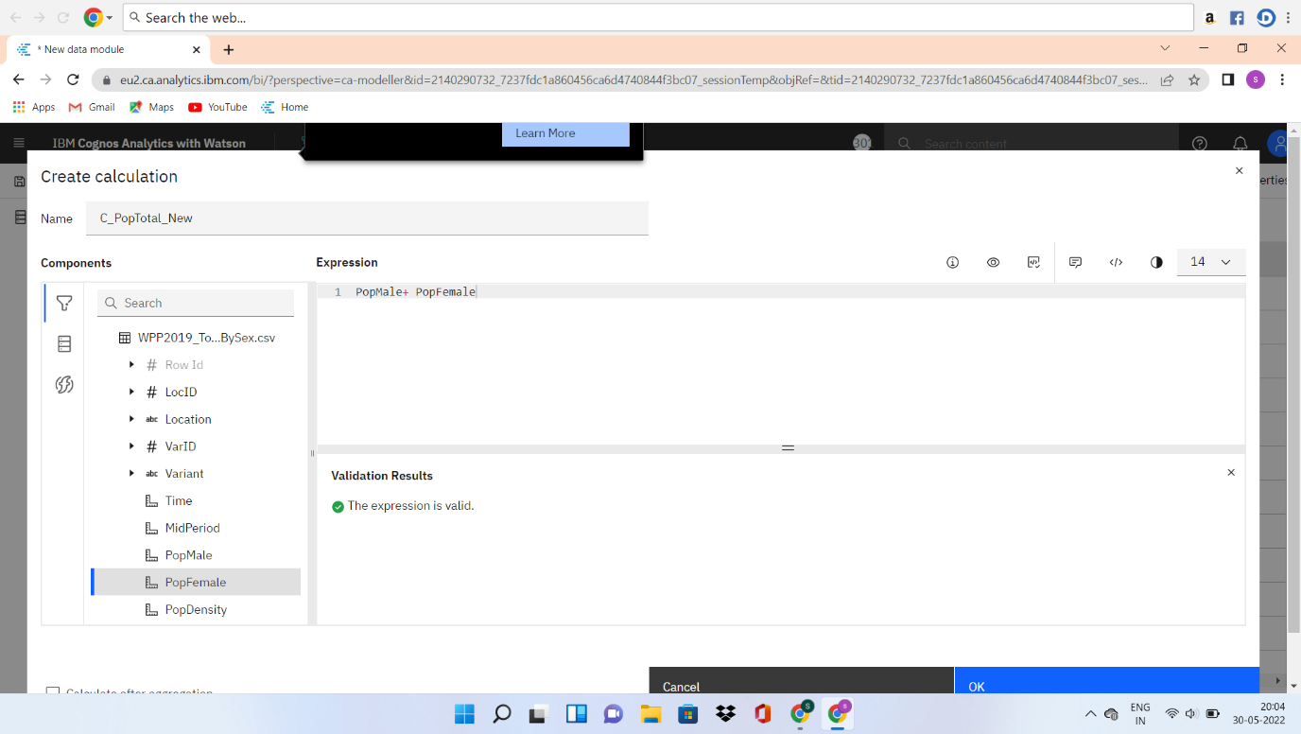

* Creation of new PopTotal column

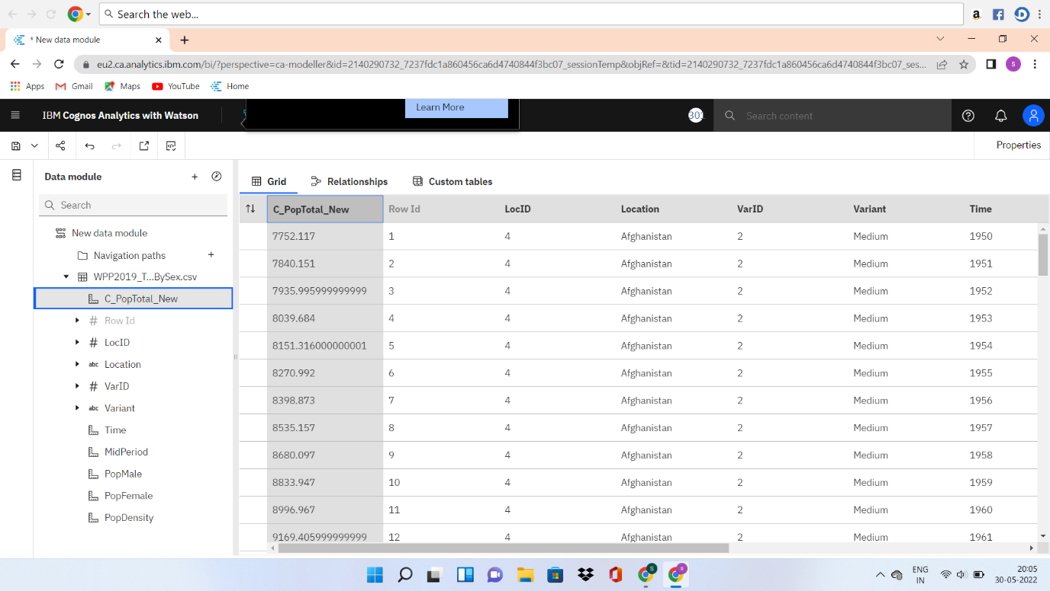

* Formate the PopMale data type

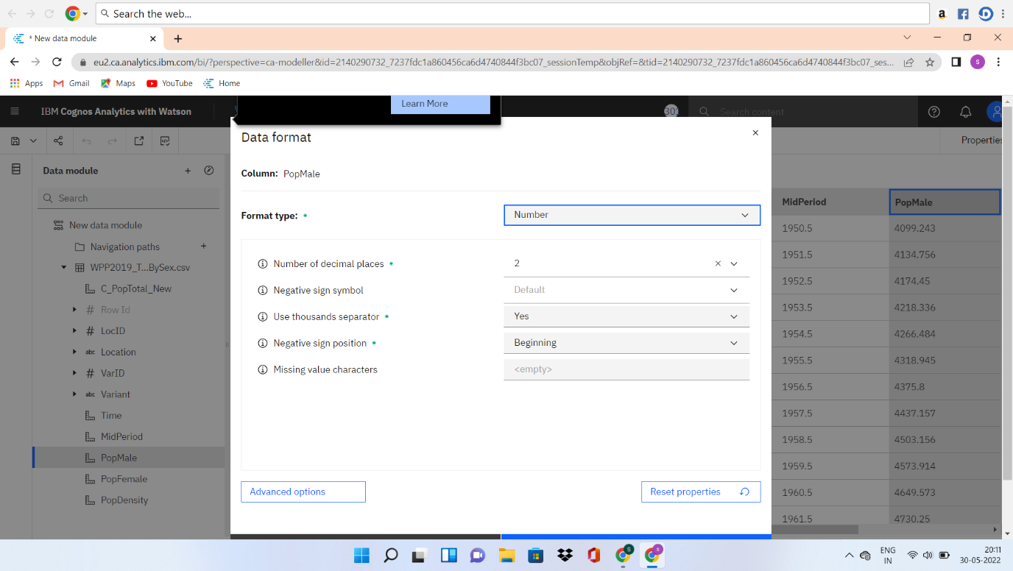

* Formate the PopFemale data type

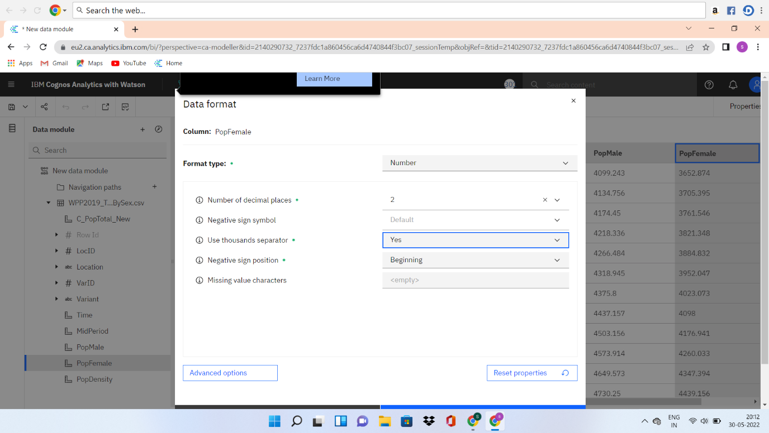

1. Data Visualization Chart

4.1 Top10 Pop Total by Location Using Tree Map

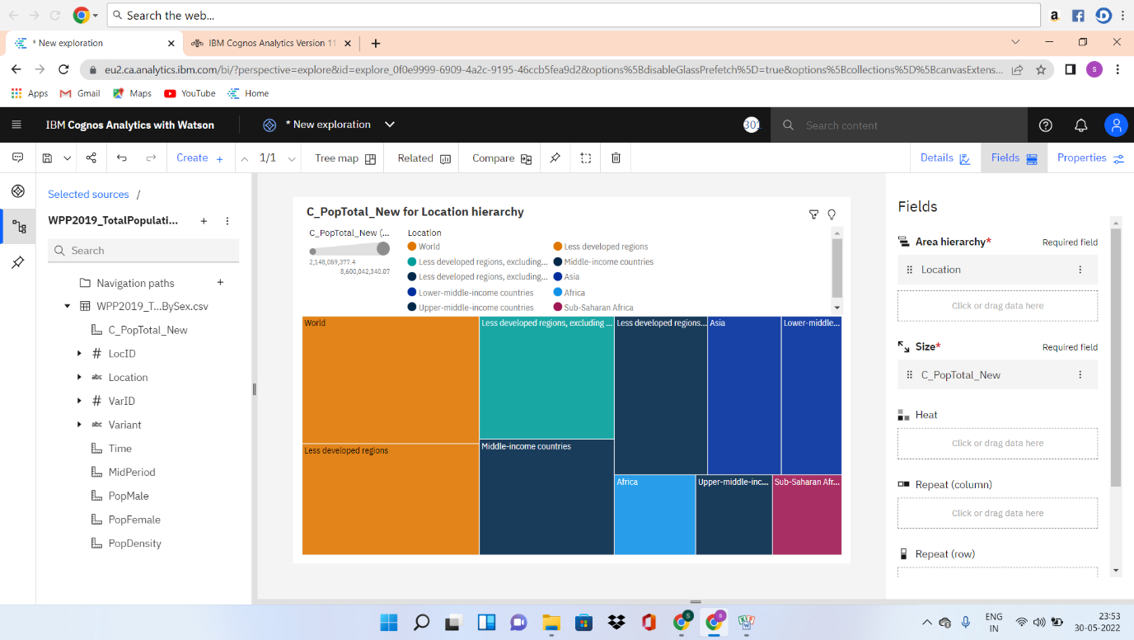

4.2 Pop Total by Time Using Line Chart

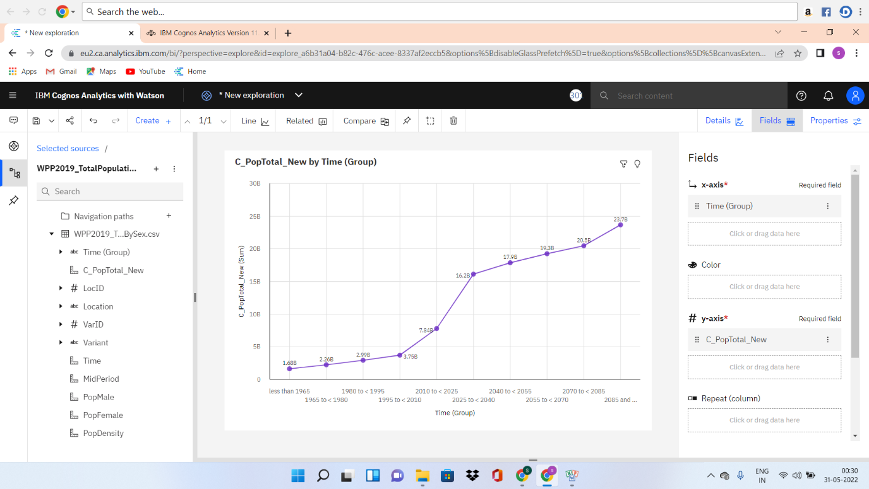

4.3 Pop Male by Location and Pop Female by Location using Pie Charts

* PopMale by Location

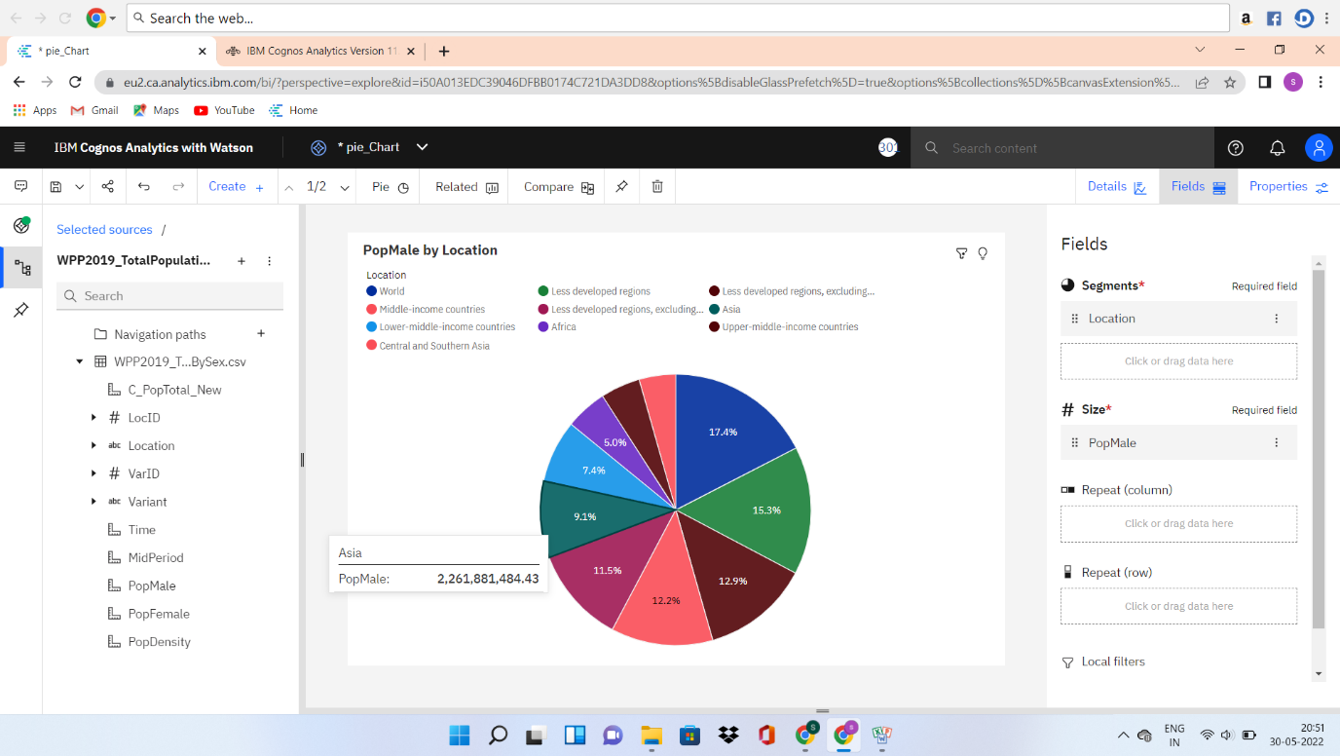

* PopFemale by Location

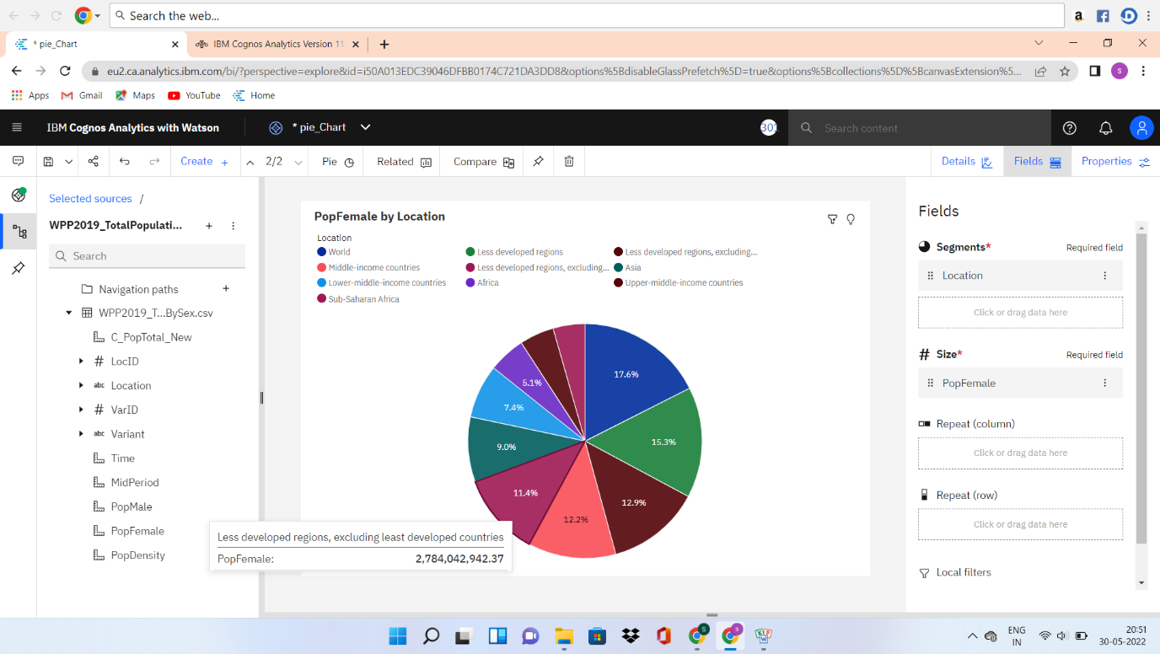

4.4 Pop Male by Time and Pop Female Using Packed Bubble Charts

* Time sized by PopMale

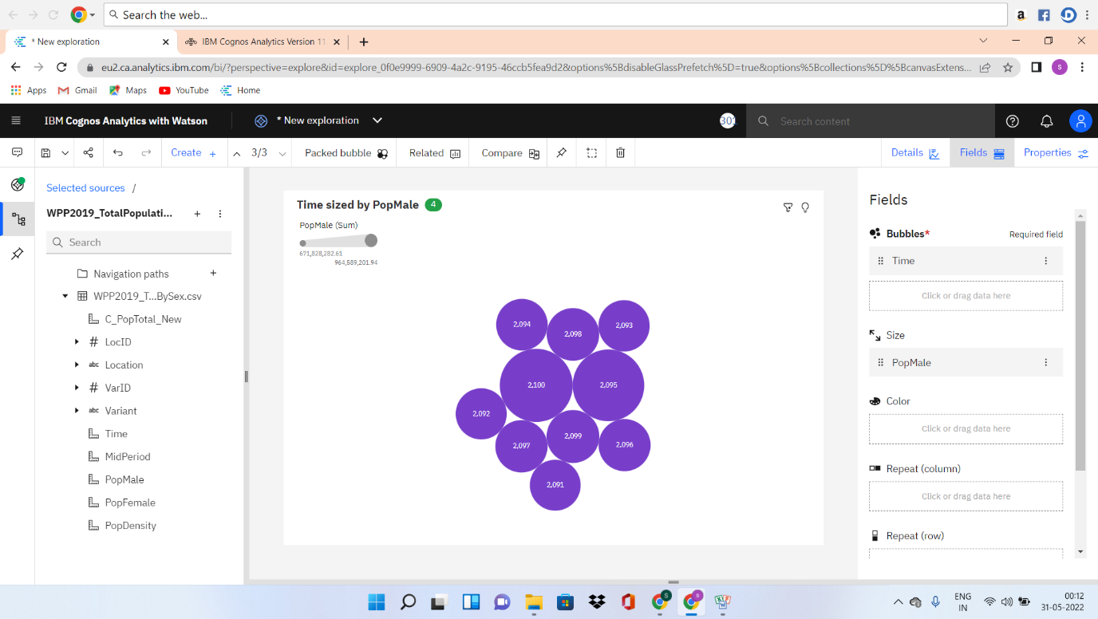

* Time sized by PopFemale

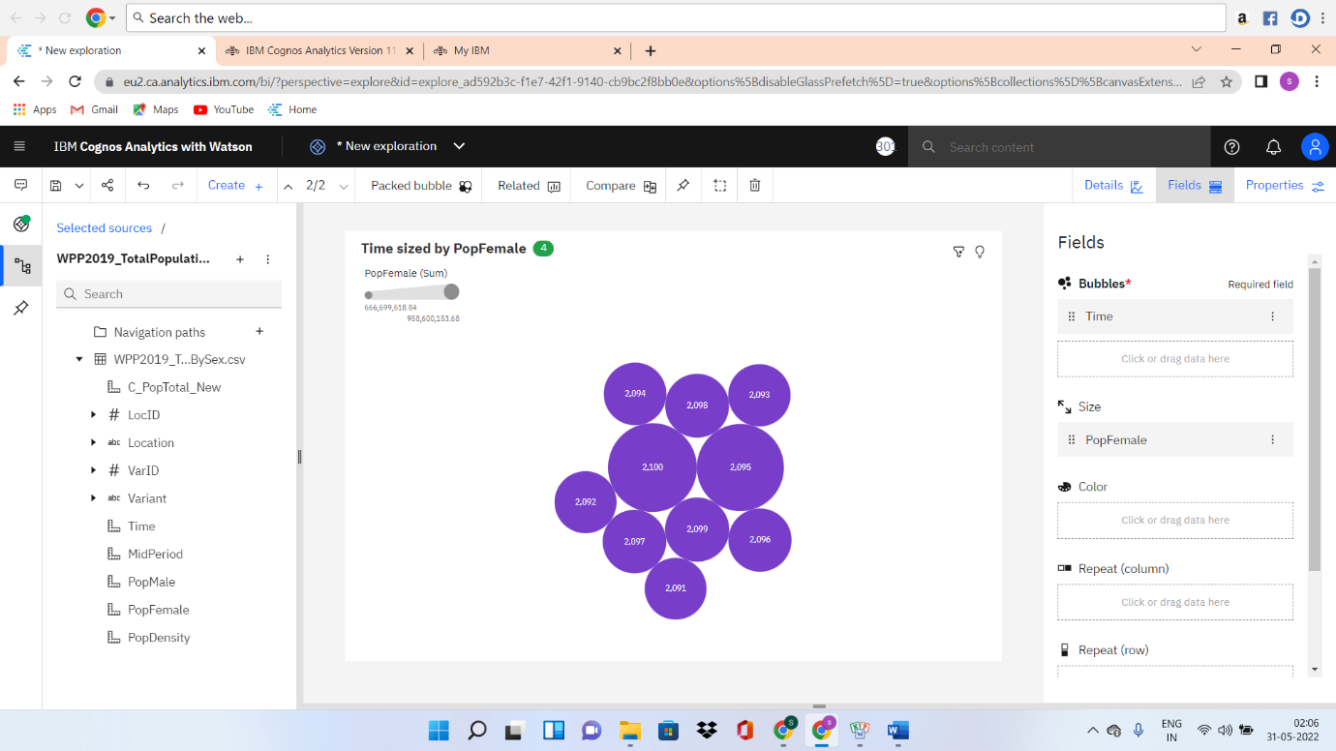

4.5 Building of Dashboard

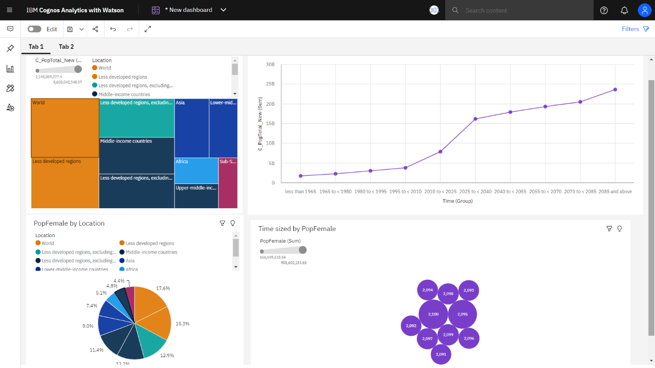

### 

4.6 Pop Male, Pop Female and Pop Total using Summary

